**CS777 – Week 1 Homework Submission “Vahid Monfared”**

**Task 1 – Top-10 Active Taxis**

Many different taxis have had multiple drivers. Write and execute a Spark Python program that computes the top ten taxis that have had the largest number of drivers. Your output should be a set of (medallion, number of drivers) pairs.

***Note****: You should consider that this is a real-world data set that might include wrongly formatted data*

*lines. You should clean up the data before the main processing, a line might not include all of the fields. If a data line is not correctly formatted, you should drop that line and do not consider it.*

* Print a list of top 10 taxis having the largest number of drivers, and the amount of drivers (taxi ID and count)

|  |
| --- |
| *('11DC93DD66D8A9A3DD9223122CF99EFD', 352)*  *('EE06BD8A621CAC3B608ACFDF0585A76A', 348)*  *('6C1132EF70BC0A7DB02174592F9A64A1', 341)*  *('A10A65AFD9F401BF3BDB79C84D3549E7', 340)*  *('23DB792D3F7EBA03004E470B684F2738', 339)*  *('7DA8DF1E4414F81EBD3A0140073B2630', 337)*  *('0318F7BBB8FF48688698F04016E67F49', 335)*  *('B07944BF31699A169091D2B16597A4A9', 333)*  *('738A62EEE9EC371689751A864C5EF811', 333)*  *('7D93E7FC4A7E4615A34B8286D92FF57F', 333)* |

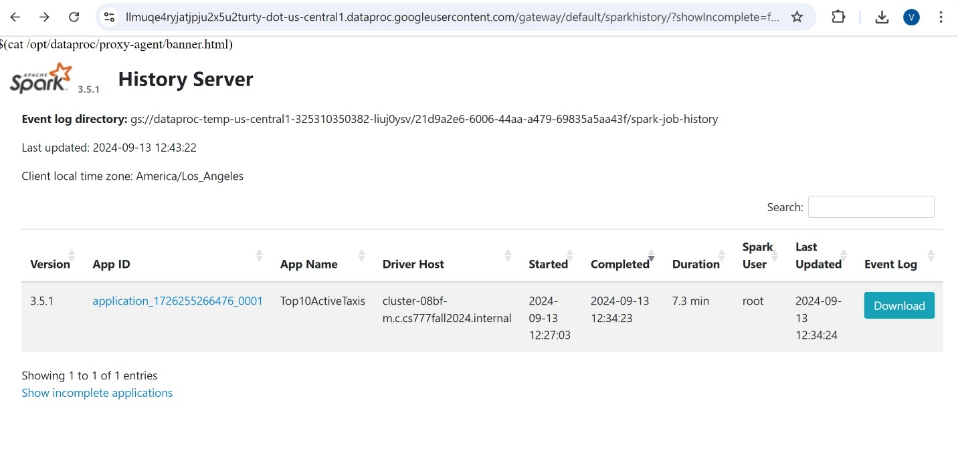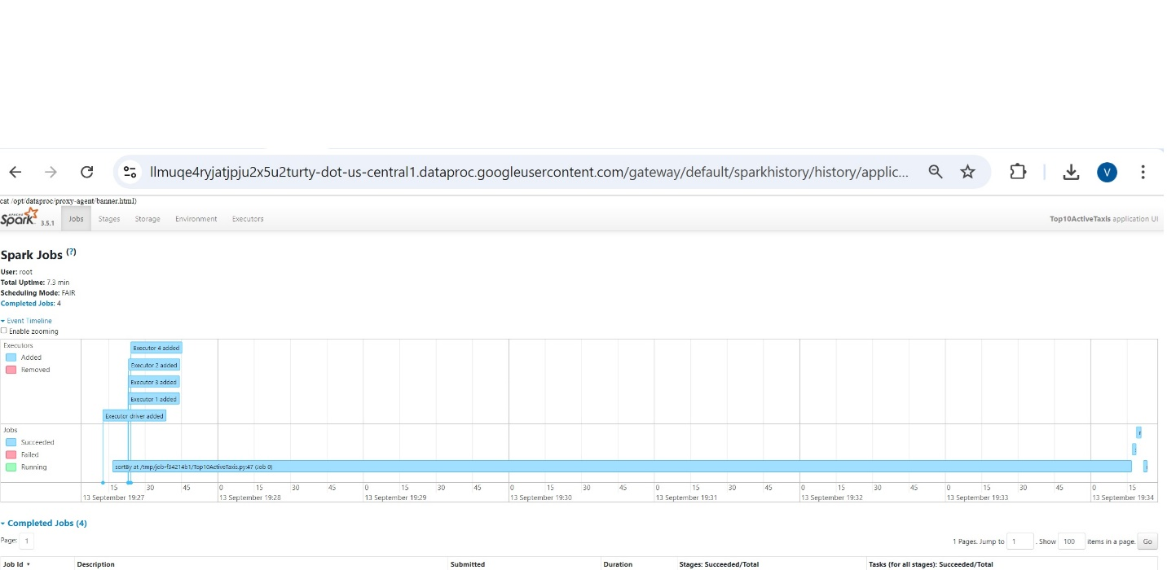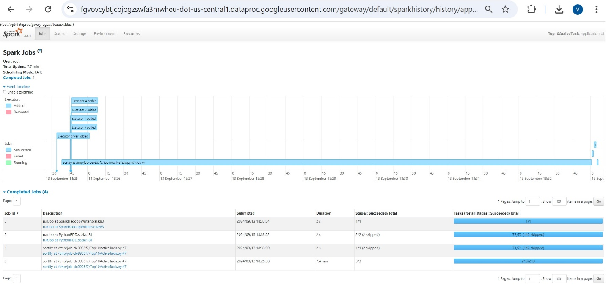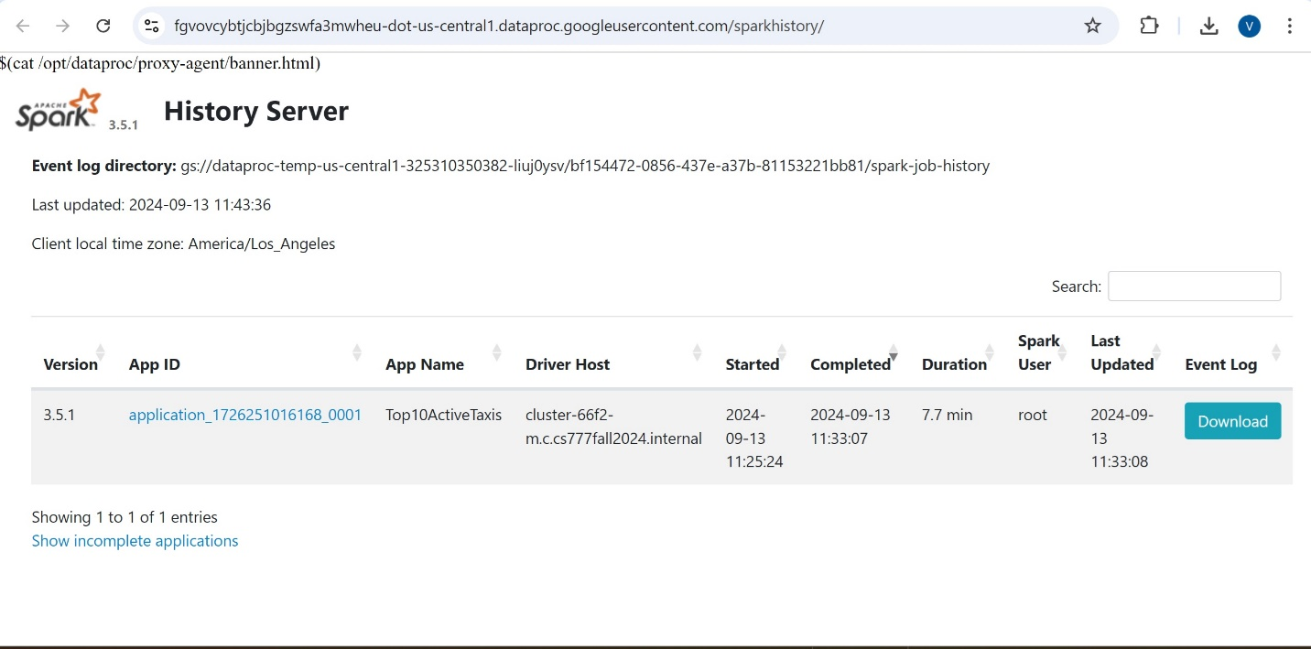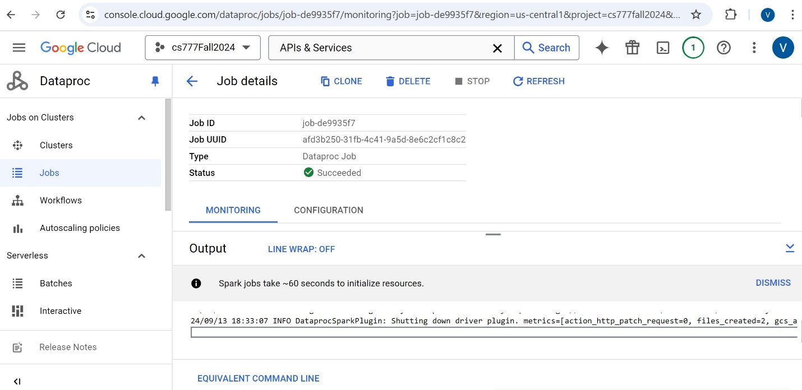

**Task 2 – Top-10 Best Drivers**

We would like to figure out who the top 10 best drivers are in terms of their average earned money per minute spent carrying a customer. The total amount field is the total money earned on a trip. In the end, we are interested in computing a set of (driver, money per minute) pairs.

* Print a list of top 10 best drivers based on earned money per minute carrying a customer (Driver ID and average earning)

|  |
| --- |
| *('E4F99C9ABE9861F18BCD38BC63D007A9', 62103.18601982026)*  *('664927CDE376A32789BA48BF55DFB7E3', 32075.6481781048)*  *('51C1BE97280A80EBFA8DAD34E1956CF6', 22412.519037907998)*  *('D85749E8852FCC66A990E40605607B2F', 21838.61138628341)*  *('23DF80C977D15141F11DD713C523C311', 20791.02908617619)*  *('3D757E111C78F5CAC83D44A92885D490', 20555.115544088956)*  *('BE047851D97506885B99BDDFA7A13360', 19584.744671992667)*  *('3AAB94CA53FE93A64811F65690654649', 19575.05448827395)*  *('74CC809D28AE726DDB32249C044DA4F8', 19558.588651912727)*  *('3578782ABD6492CEB927B2A8EBCF1402', 19321.71774748813)* |

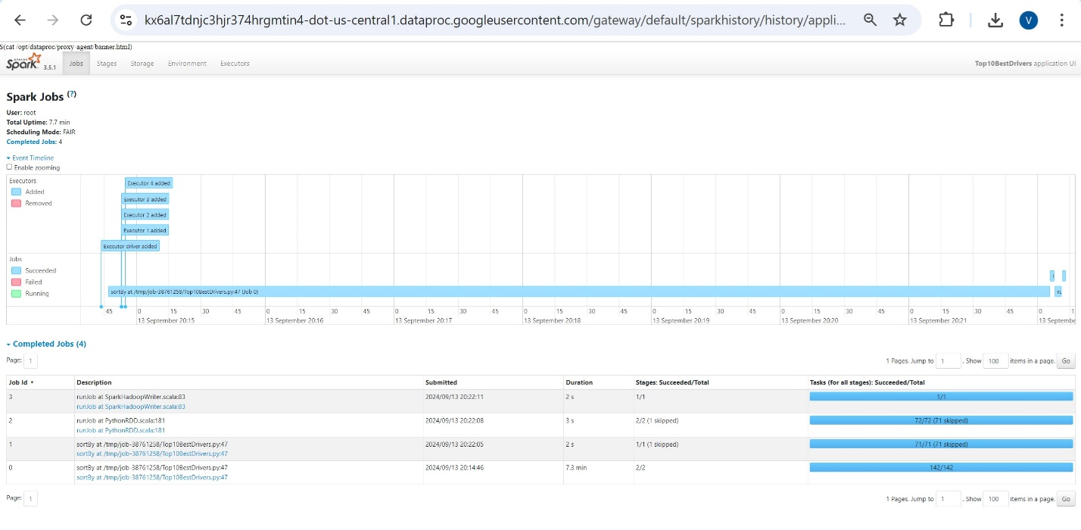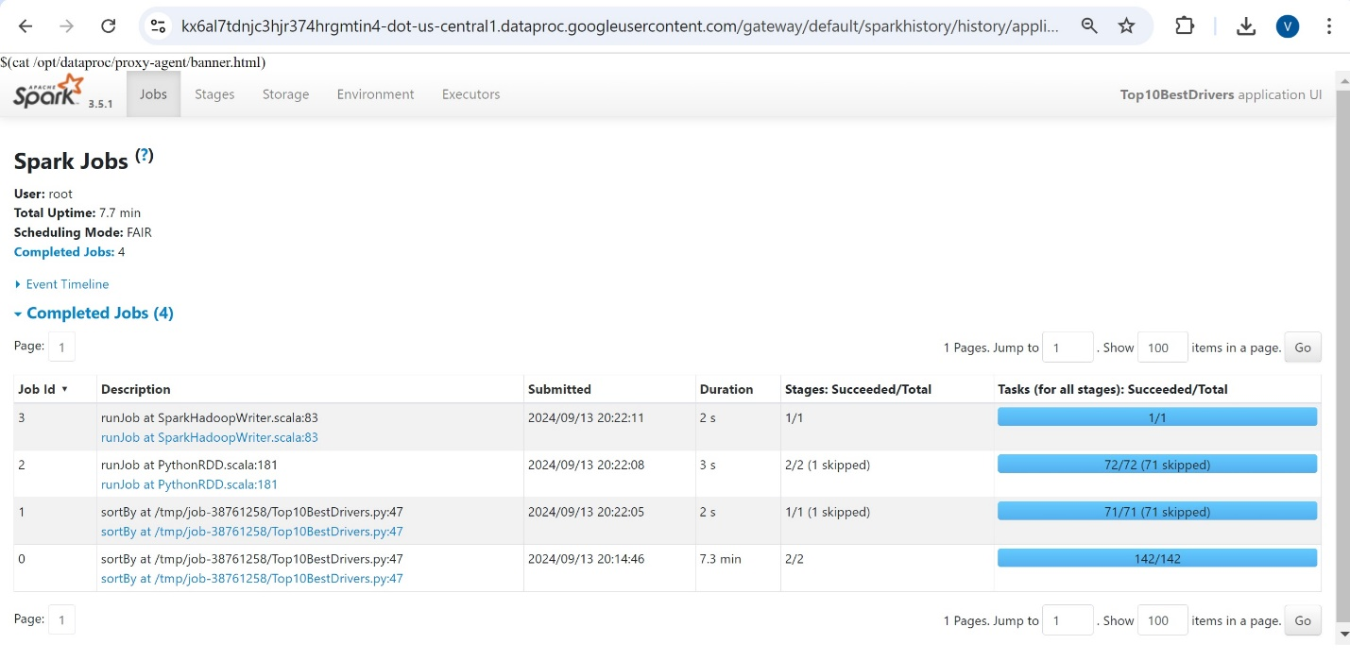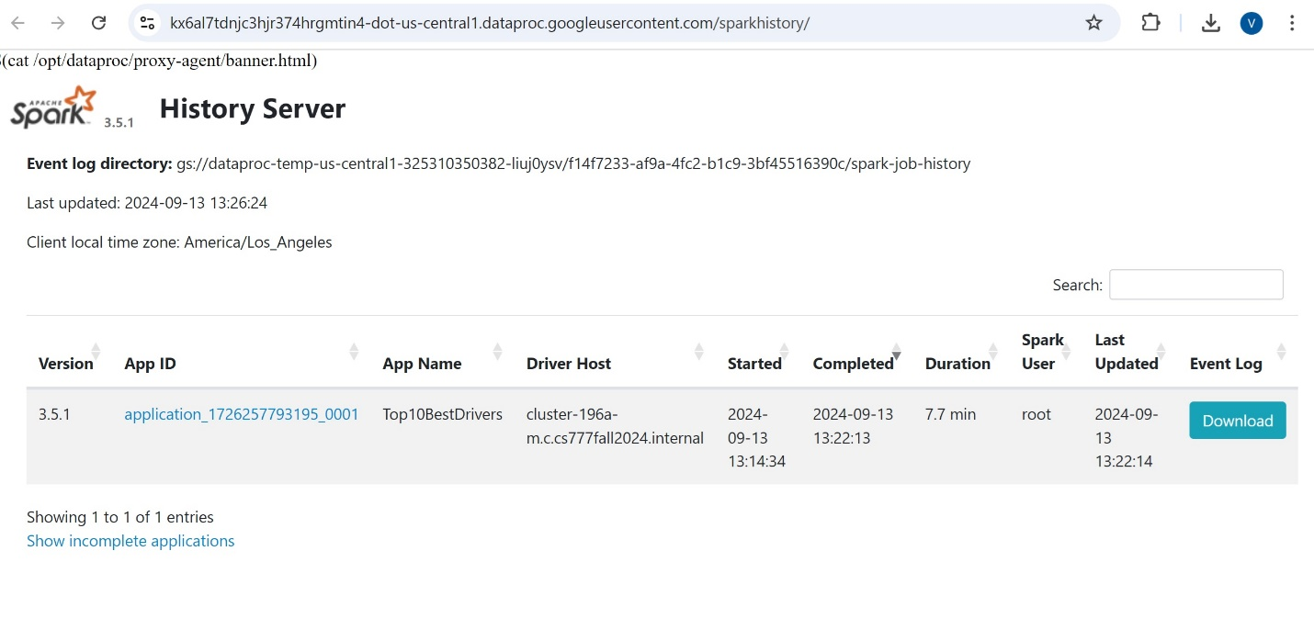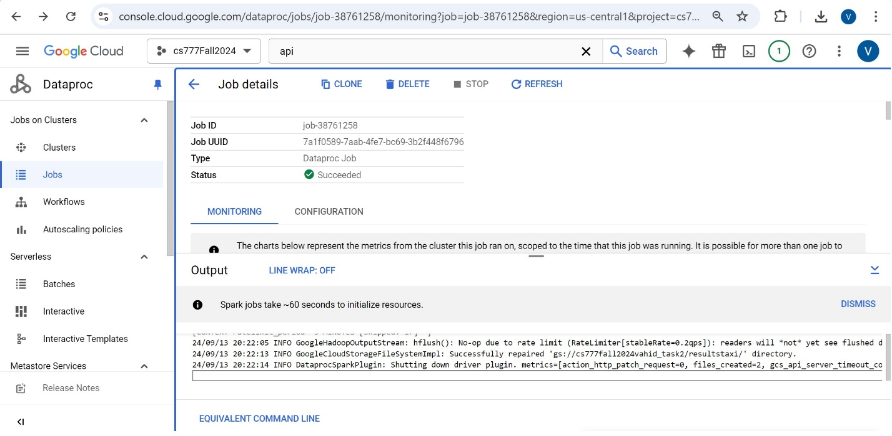

**Task 3 – The best time of the day to Work on Taxi (For Advanced Students - no points)**

We would like to know which hour of the day is the best time for drivers that has the highest profit per mile. Consider the surcharge amount in dollars for each taxi ride (without tip amount) and the distance in miles, and sum up the rides for each hour of the day (24 hours) – consider the pickup time for your calculation. The profit ratio is the ration surcharge in dollars divided by the travel distance in miles for each specific time of the day.

Profit Ratio = (Surcharge Amount in US Dollar) / (Travel Distance in miles)

We are interested to know the time of the day that has the highest profit ratio.

* Print the profit ratio for the best hour of the day exhibiting the highest profit per mile

|  |
| --- |
| *(18, 0.5998318861259467)* |

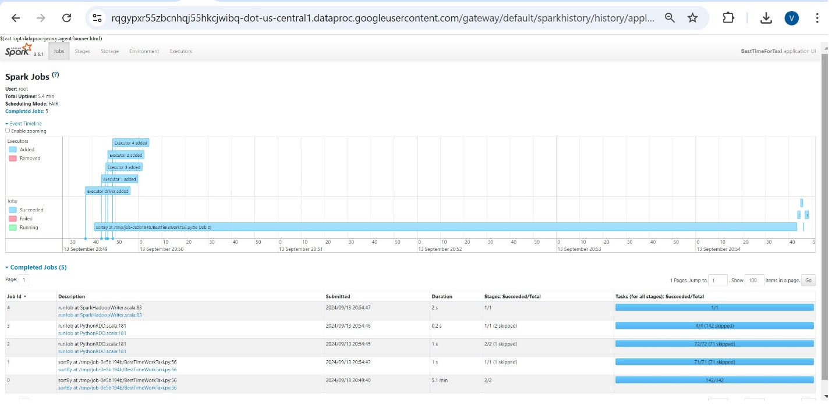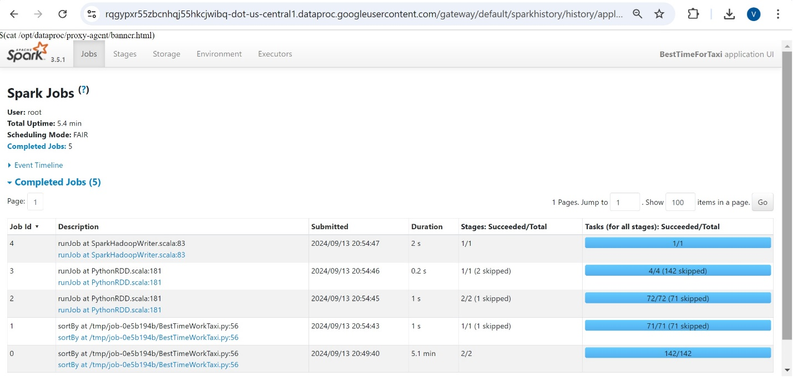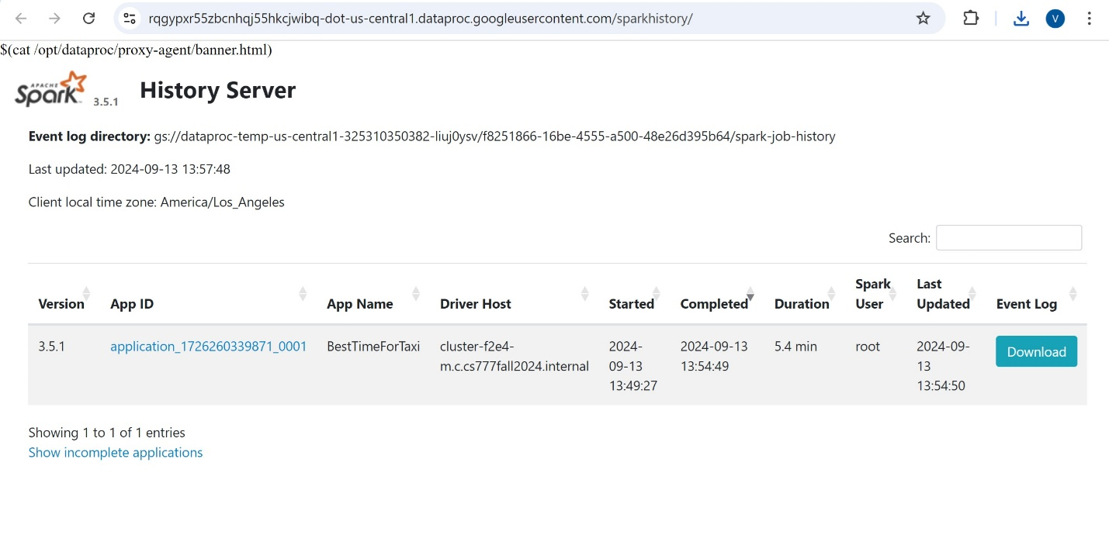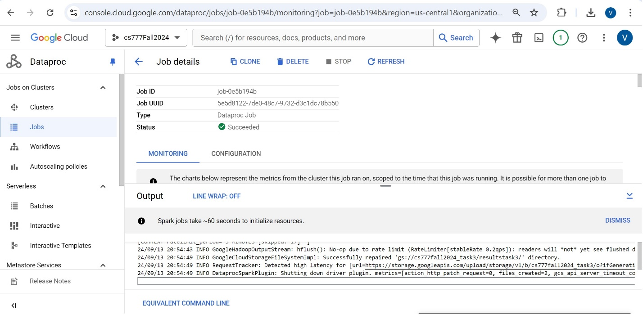

**Task 4 - (For Advanced Students - no points)**

Here are some further tasks for advanced groups.

a) How many percent of taxi customers pay with cash, and how many percent use electronic cards? Analyze these payment methods for different times of the day and provide a list of percent for each time of the day? As a result, provide two numbers for total percentages and a list like: hour of the day, percent paid card.

* For each hour of the day, provide percentages of customers paying with cash and cards

|  |
| --- |
| *(0, 56.56)*  *(1, 56.16)*  *(2, 55.82)*  *(3, 54.43)*  *(4, 48.83)*  *(5, 51.68)*  *(6, 54.85)*  *(7, 57.59)*  *(8, 59.93)*  *(9, 57.88)*  *(10, 52.75)*  *(11, 50.95)*  *(12, 50.63)*  *(13, 50.07)*  *(14, 49.75)*  *(15, 49.19)*  *(16, 49.46)*  *(17, 51.5)*  *(18, 54.12)*  *(19, 55.76)*  *(20, 57.8)*  *(21, 57.52)*  *(22, 57.34)*  *(23, 57.18)* |

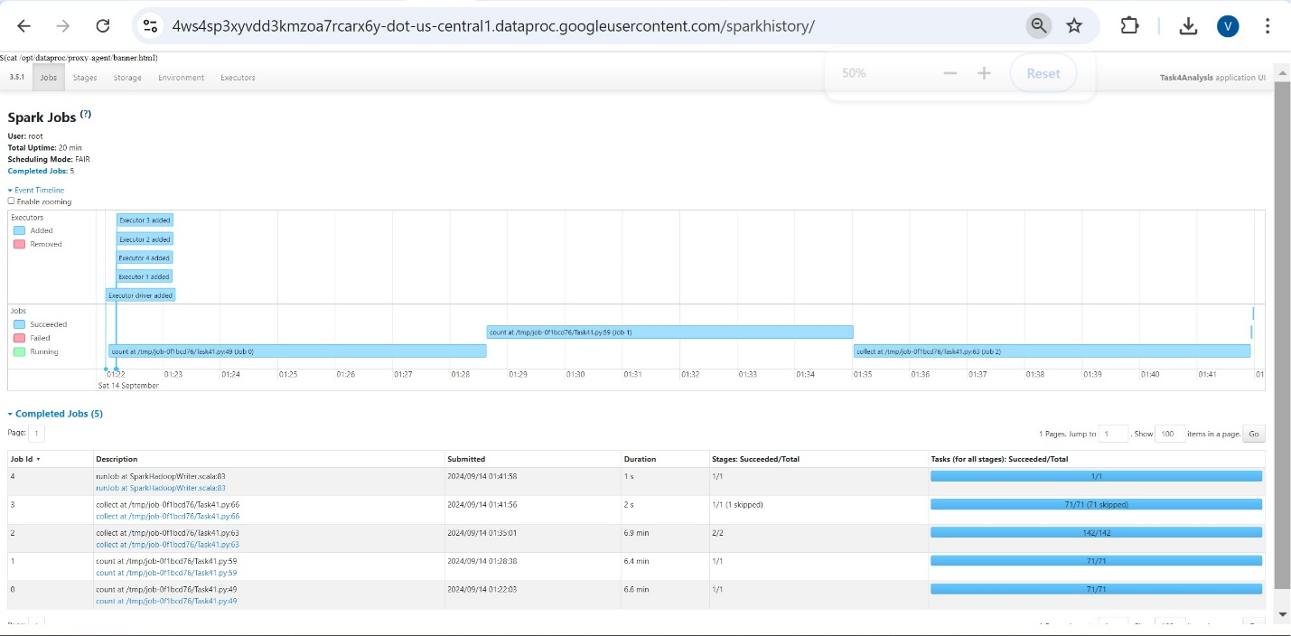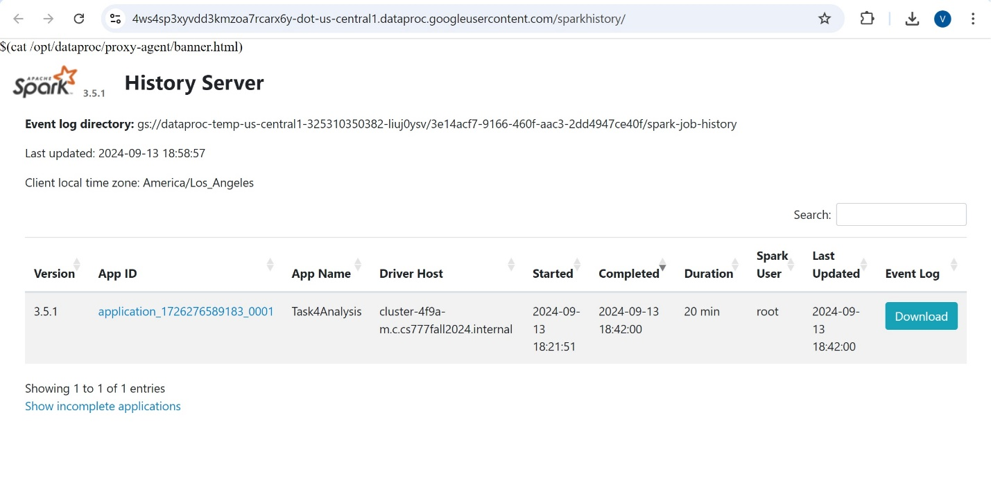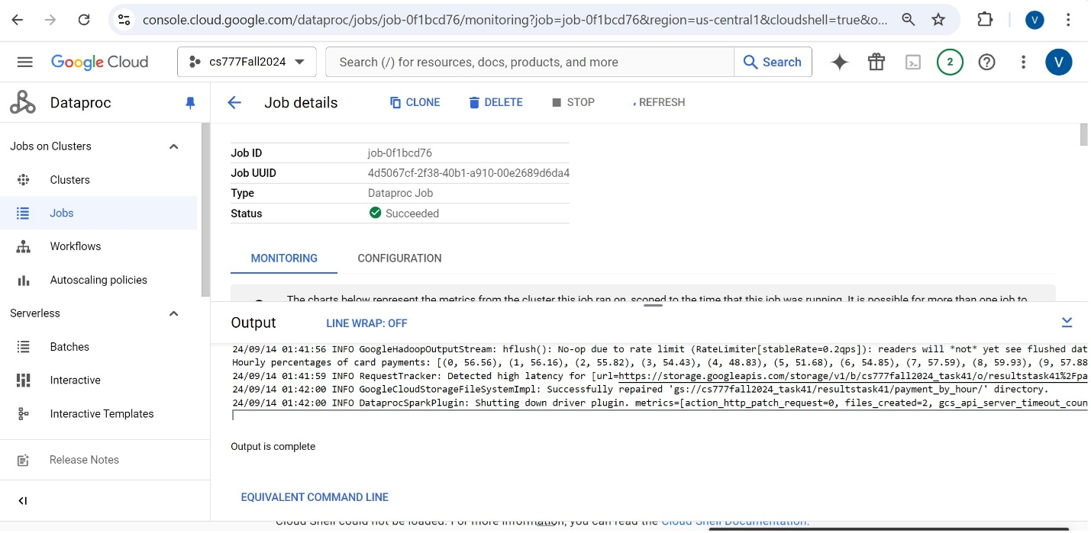

b) We would like to measure the efficiency of taxi drivers by finding out their average earned money per mile. (Consider the total amount, which includes tips, as their earned money) Implement a Spark job that can find out the top-10 efficient taxi drivers.

* Find the top 10 taxi drivers with highest average earned money per mile

|  |
| --- |
| *('E4F99C9ABE9861F18BCD38BC63D007A9', 62103.18601982026)*  *('664927CDE376A32789BA48BF55DFB7E3', 32075.6481781048)*  *('51C1BE97280A80EBFA8DAD34E1956CF6', 22412.519037907998)*  *('D85749E8852FCC66A990E40605607B2F', 21838.61138628341)*  *('23DF80C977D15141F11DD713C523C311', 20791.02908617619)*  *('3D757E111C78F5CAC83D44A92885D490', 20555.115544088956)*  *('BE047851D97506885B99BDDFA7A13360', 19584.744671992667)*  *('3AAB94CA53FE93A64811F65690654649', 19575.05448827395)*  *('74CC809D28AE726DDB32249C044DA4F8', 19558.588651912727)*  *('3578782ABD6492CEB927B2A8EBCF1402', 19321.71774748813)* |



c) What are the mean, median, first, and third quantiles of tip amount? How do you find the median?

* Print the mean, median, first and third quantiles of the tip amount

|  |
| --- |
| *Mean Tip: 1.365121487449525*  *Median Tip: 1.0*  *Q1: 0.0*  *Q3: 2.0* |

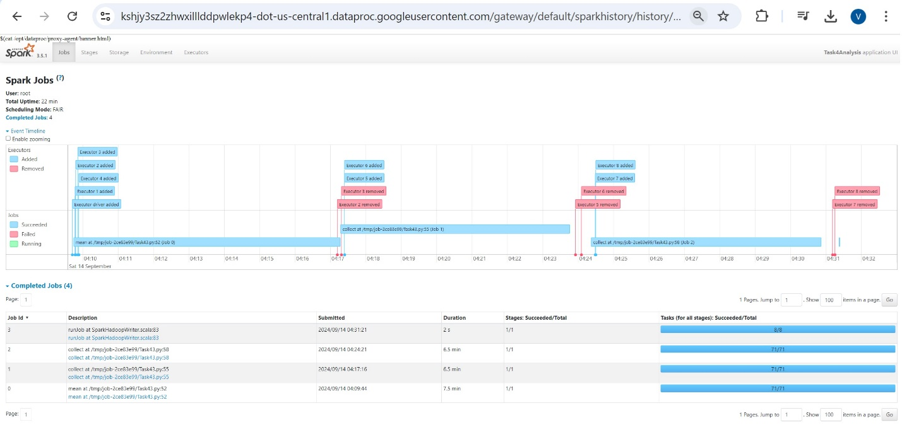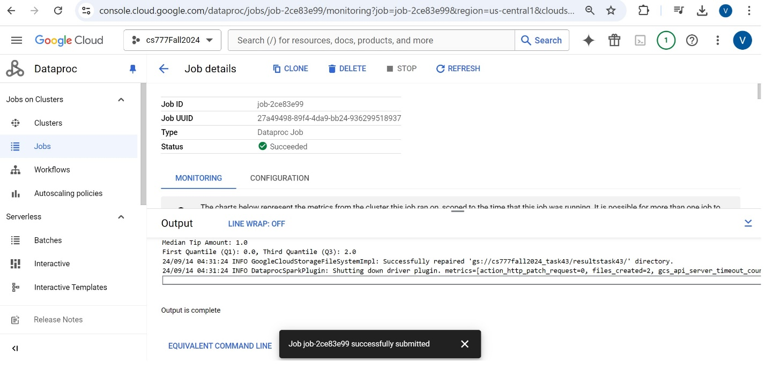

* Explain how do you find the median

|  |
| --- |
| the median is calculated using PySpark's approxQuantile function.  The median is calculated as the 50th percentile (or second quartile, Q2) of the "tip_amount" column using the approxQuantile function. This method is efficient for large datasets and provides an approximate result with a specified error tolerance (0.01 in this case, meaning a 1% tolerance). |

d) Using the IQR outlier detection method, find out the top-10 outliers.

* Find the top 10 outliers

|  |
| --- |
| *Top 10 Outliers: [685908.1, 541432.56, 159001.16, 82241.97, 61553.03, 9000.65, 7683.47, 7659.17, 7658.47, 5661.47]* |

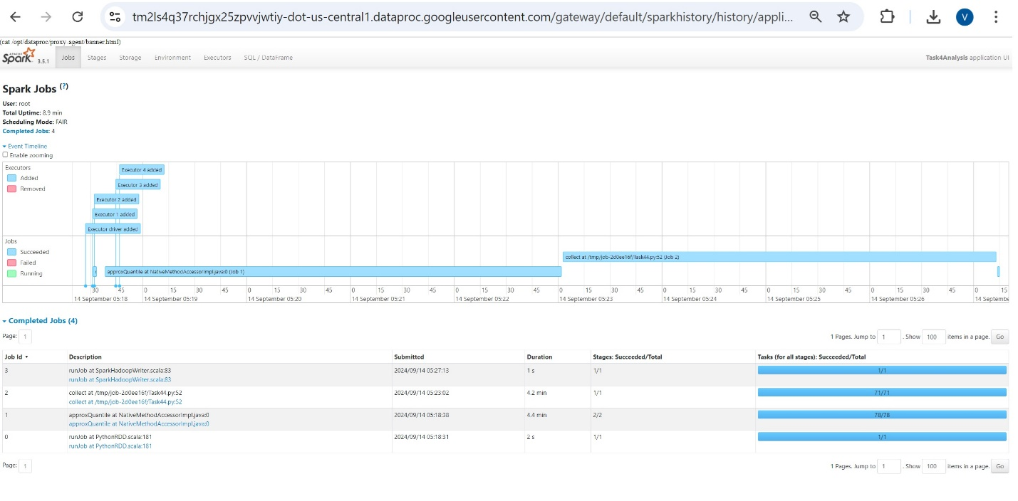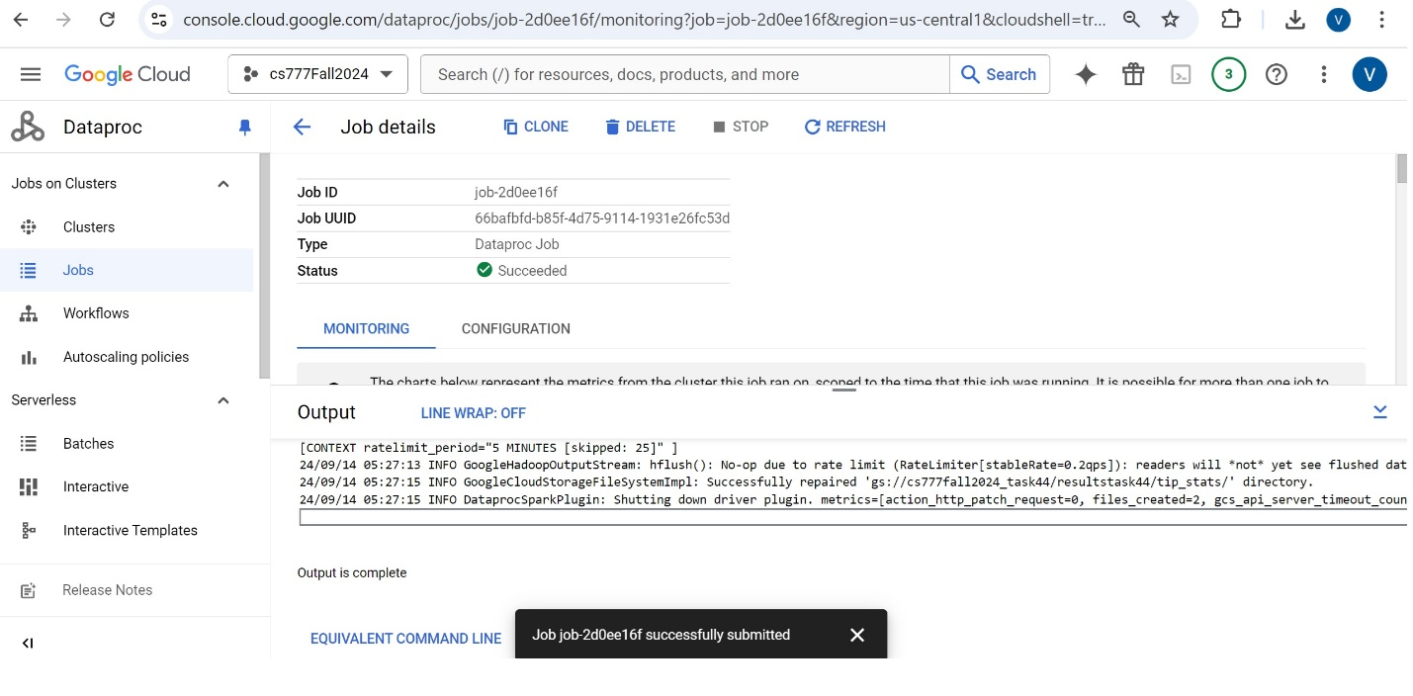

**Spark History Output:**

To demonstrate that you did execute your code on the cloud it is important to include URLs in the screenshots. Otherwise, there is no way for us to verify if the code was executed in your cloud account.

**Task 1:**

|  |
| --- |
|  |

**Task 2:**

|  |
| --- |
|  |